
https://atlas.cid.harvard.edu/

Optimal Industry Development Strategy Using Economic and Product Complexity

Colombia

─

The Economic Complexity Lab - Columbia University
Haoxian Chen, Davepriyan Gunaratnam, Rohan Macherla, Ajit Akole, Shomik Ghose, Alex Wei-Liang Ku, Sannidhya Modi, Xilin Wang, Alexandra Garcia, Kelly Mi, Alex Chung, Margarita Demkina
Optimal Industry Development Strategy for Colombia

0. Executive Summary

In this report, we aim to uncover the economic path Colombia went through during the period from 2013 to 2021. Specifically, we dive into the topic through a macroeconomic overview of Colombia from the perspective of Gross Domestic Product (GDP) and Economic Complexity Index (ECI), which reflect countries’ production capability and production structure, respectively. We find that during the period of our interest, Colombia demonstrated a low level of economic growth with an annual GDP growth rate of -1.2% from 2013 to 2018 and 0.2% from 2019 to 2021, concurrent with a stagnant economic complexity as compared with other major economies in South America and beyond.

The level of economic progress during the first period can be partially explained through the analysis of the economic and product complexity structure of Colombia on the industry group level. The product classification system we adopt allows us to measure the realized industry development for various industry groups and to observe that Colombia invested heavily in developing Services and Utilities, Metals, and Vegetables, Fruits and Plants during the period, while its emerging peers and developed economies around the globe have adopted much more complex and progressive paths.

Based on our analysis of the opportunity gain and sensitivity analysis of major industry groups, Colombia can further its gains by prioritizing Machinery and Construction and Chemical Manufacturing in 2018. We further note that Colombia has a slightly mismatched development strategy that indicates a moderate level of structural optimality on the complexity level, having an adjusted R-square of around 0.054 in 2018 compared to 0.023 in 2021. Since a significant positive correlation exists between five-year GDP growth and the structural optimality index of an economy as we define and calculate, Colombia indeed has a suboptimal growth experience as compared with fast-growing economies both on a regional scale and on a global scale and has the potential to further its economic gains through industrial structure optimization as suggested in the paper.

The three years following showed a significant improvement in Colombia's economic growth, boosting its position on the global scale. Its GDP recovered to above the pre-pandemic levels, and it saw a significant boost in the ECI, particularly compared to its peer countries. its focus should have shifted to the Animals and By-products and Transportation industries. We further note that Colombia has a heavily mismatched development strategy that indicates a low level (compared to other emerging countries) of structural optimality on the complexity level, as indicated by a very low adjusted R-square, demonstrating stagnation in development. Its current strategy still has the viable potential upside to increase its performance and optimize its structure further.

1. Report Overview

In this report, we aim to uncover the economic path Colombia went through during the period from 2019 to 2021, before and after the COVID pandemic, compared to its performance from 2013 to 2018. Specifically, we dive into the topic through a macroeconomic overview of Colombia from the perspective of Gross Domestic Product (GDP) and Economic Complexity Index (ECI), which reflect countries’ production capability and production structure, respectively. We then analyze the industrial framework and changes of Colombia during the period based on quantitative measures such as the Product Complexity Index (PCI) and Product Family Complexity Index (PfCI), followed by a detailed analysis of how such changes have matched with development strategies as quantitatively measured by opportunity gains on an industry-level. We conclude our report with macro-level results and predictions of Colombia, as deduced from regression models we have established on a global scale, which take into account countries’ stances in their product space.

2. Macroeconomic Results

2.1 GDP Ranking and Changes
As the 38th largest economy in the world by GDP in 2018, Colombia has a GDP of 381 billion USD in 2013 and 331 billion USD in 2018, exhibiting a steady economic output. Figure 1a illustrates the time-series GDP results for major emerging economies from 1999-2018, and Colombia demonstrates a high level of consistency in terms of GDP with small GDP growth. Its growth rate is not significant as compared with many other emerging economies in the world, with an average annual growth of -1.2% during the period from 2013 to 2018. This number is much smaller than the average annual growth rate of China, Mexico, and Saudi Arabia, which have a geometric average growth rate of 1.8% and an arithmetic average growth rate of 2.1%. The contrast is particularly significant with China, one of the leading emerging economies in the world, which has an average annual growth rate of 8.2% during the same period. The pace of economic growth in Colombia, we believe, can be reflected through changes in ECI and PCI and can be further explained by a suboptimal set of production strategies adopted by Colombia from 2013 to 2018, which we will expand at the later stage of the report.

Figure 1b shows the GDP levels for Colombia and its peer countries (Mexico, Saudi Arabia, and Tunisia) from 2019 to 2021. Similar to the other countries, Colombia displayed a drop in GDP from 2019 to 2020 because of the pandemic, with most GDPs approaching pre-pandemic levels in 2021. Over these three years, Colombia’s average annual GDP growth rate (-0.02%) is the lowest compared to Saudi Arabia’s (2.01%), Tunisia’s (3.98%), and Mexico’s (1.53%).

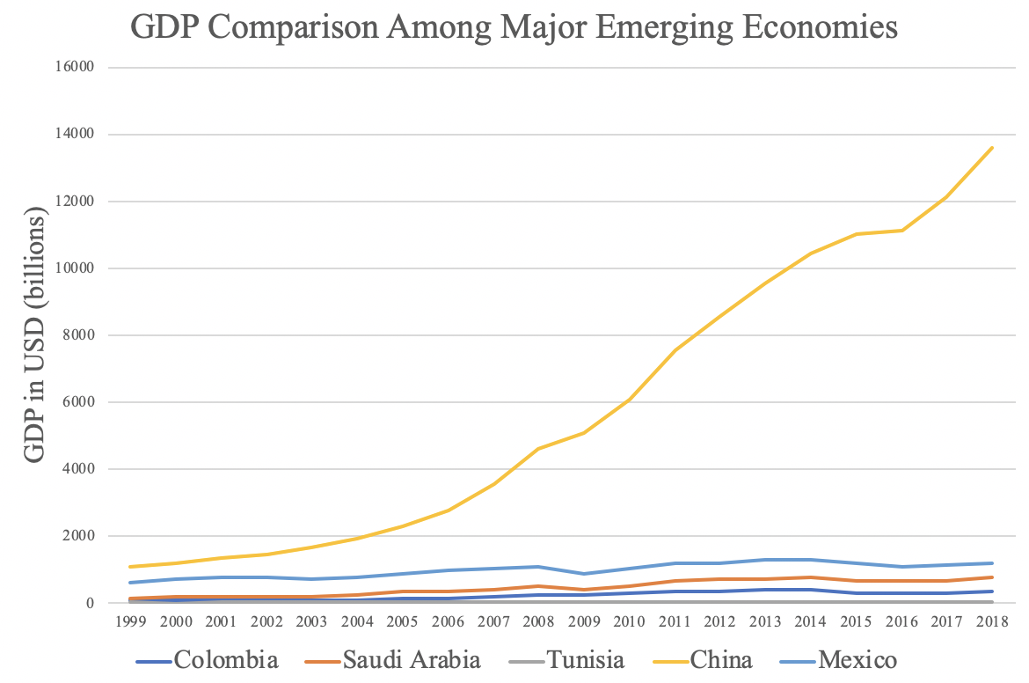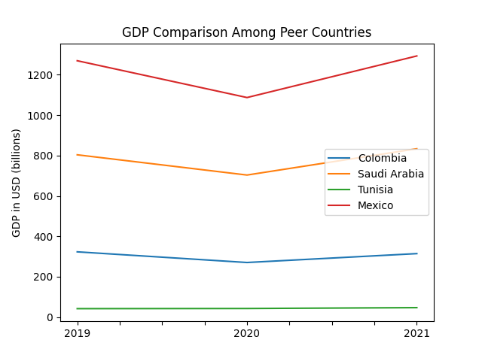
Figures 1a and 1b. GDP Comparison Among Peer Countries (left: 2013-2018; right: 2019-2021)

2.2 ECI Ranking and Changes
The Economic Complexity Index (ECI), as defined by Ricardo Hausmann and Cesar Hidalgo in 2009 to explain the knowledge accumulated in a country's population, is illustrated in Figures 2a and 2b.

As illustrated in Figure 2a below, Colombia exhibits a stably low level of production capability from 2013 to 2018, as measured by ECI. This is in direct contrast to countries such as China and Mexico, which demonstrate a steady trend in terms of both the ECI and GDP indexes.

The comparable countries underwent a drastic change in ECI level between 2019 and 2020, with a sharp change between 2020 and 2021, except for Colombia. It exhibits a large increase in production capability in 2021, with extensive microeconomic stimulus packages being one of the reasons. Colombia has seen a 168% increase in its ECI, which is greater than all of its peers’ (-111% for Saudi Arabia, -180% for Tunisia, and -197% for Mexico).

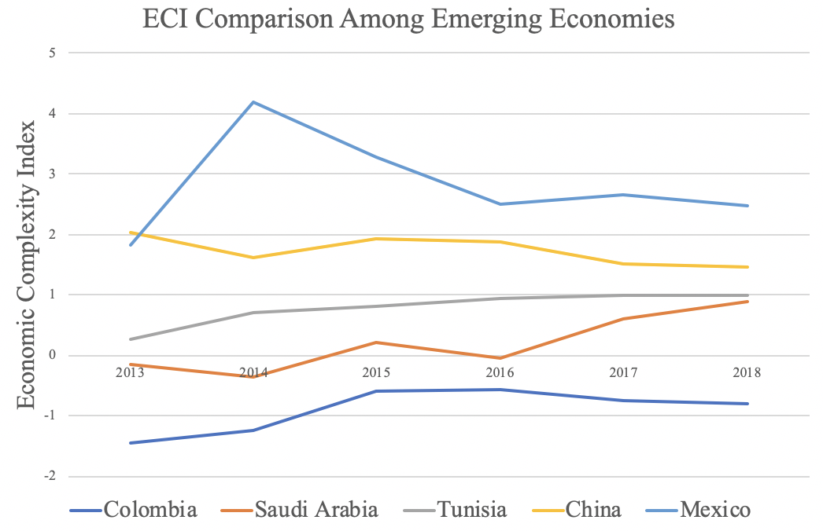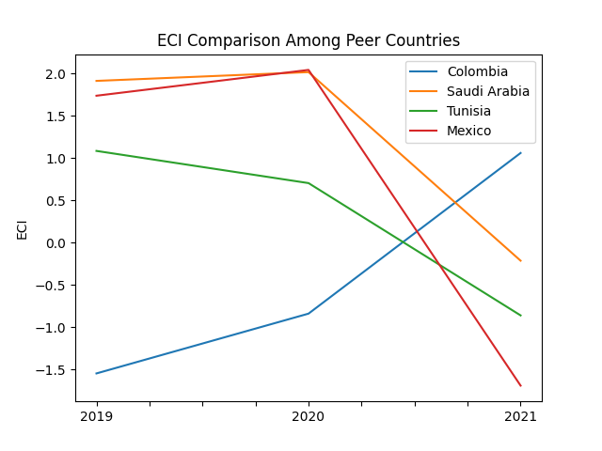
Figures 2a and 2b. ECI Comparison Among Peer Countries (left: 2013-2018; right: 2019-2021)

Figures 3a and 3b offer a further comparison of GDP Growth and ECI over the time span from 2013 to 2021 for Colombia. From the graphs, it can be observed that changes in GDP during the period from 2013 to 2018 are not consistent with the changes in ECI, indicating the small predictive power of ECI in terms of Colombia’s potential economic development. In order to get a better insight into the relationship between ECI and the country’s economy, we will dive into an analysis of Colombia’s production structure and its product space designs in the next few chapters. It is the opposite for GDP and ECI from 2019 to 2021, when the ECI followed GDP trends more closely, which can be interpreted as advancements in production. In order to provide a more concrete answer to why this has happened, we will dive into an analysis of Colombia’s production structure and its product space designs in the next few sections.

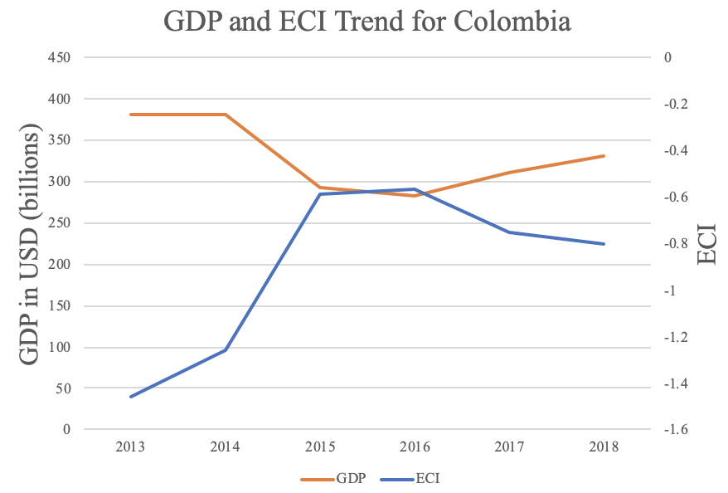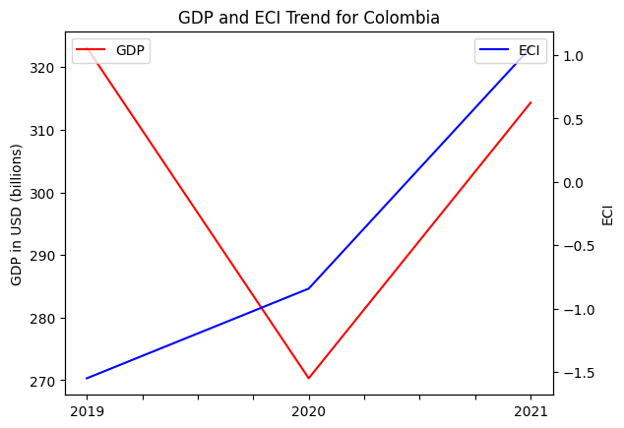
Figures 3a and 3b. GDP Growth and ECI for Colombia (left: 2013-2018; right: 2019-2021)

3. Production Analysis

3.1 Product Categorization
Our main data source in this research is the UN Comtrade Website (https://comtrade.un.org), which provides us with valuable information on countries’ export values on an annual basis, including highly specific export data for more than 5000 categories of products. In order to have a holistic vision of the product space of a country, however, a level of categorization is required. Products in our data source are labeled from 010000-999999, with the first two digits representing a general category to which the product belongs. Based on the 99 categories extracted from the label, we further group the products into the 18 most widely-accepted industries, as summarized in Table 1.

Note that the High-complexity Products industry group is not a distinct industry but rather an aggregated industry that encompasses the most complicated products from the most technologically-advanced industries (as measured by PCI). This industry serves as an indicator for us to quantitatively evaluate how well a country has performed in developing cutting-edge technologies and closing its technological gap with advanced economies, which has become a topic of wide concern today. Indeed, when we rank the 18 categories based on PfCI (an equivalent concept of PCI as calculated based on the 18 categorized product groups), the High-complexity Products industry has the highest PfCI among all industry groups.

Category | Description
Animals and By-products | All kinds of meat, livestock and related by-products
Vegetables, Fruits and Plants | All kinds of plants, edible vegetables and fruits
Food and Preparations | Edible preparations, raw cooking materials and appliances
Clothing and Accessories | All kinds of fabrics, filament, clothing and accessories
Textiles | All kinds of textile articles and related products
Wood Products | Book, paper and other elementary products related to wood
Metals | Mining of all sorts of raw Metals
Refined and Processed Stones | Refined or processed stone products such as pearl and ceramics
Energy Drilling and Mining | Mining industry for energy, minerals, stone materials, etc.
Daily Instruments | Basic daily instruments such as sport requisites, timing and measuring tools
Raw Manufacturing | Basic products made from plastic, rubber, leather, etc.
Chemical Manufacturing | Advanced chemical products and pharmaceutical products
Chemicals | Raw chemical materials and by-products
Machinery and Construction | Machinery and mechanical appliances, including electrical equipment
Transportation | Vehicles and locomotives including aircraft, ship, railway, etc.
Weapons | Explosives, arms and ammunition
Services and Utilities | Financial, business, legal, communication, travel Services and Utilities, etc.
High-complexity Products | Agglomeration of advanced products with highest PCIs
Table 1. Categorization of Products

We further observe a positive correlation between the GDP and the export of High-complexity Products. A higher adjusted R-square exists between GDP and High-complexity Products exports, indicating that more successful economics, as measured by GDP, tend to be those that are capable of producing and exporting High-complexity Products as we define them. Tables 2a and 2b show the OLS results in a universe of 107 and 21 typical countries respectively.

 | High-complexity Products | Food and Preparations | Animals and By-products
Adj. R-squared | 0.075 | 0.006 | 0.002
F-statistic | 9.556 | 1.638 | 1.175
No. Observations | 107 | 107 | 107
Table 2a. OLS Regression Results of GDP against Percentage Volume of Exports

 | High-complexity Products | Food and Preparations | Animals and By-products
Adj. R-squared | 0.149 | 0.003 | -0.012
F-statistic | 4.510 | 1.059 | 0.7542
No. Observations | 21 | 21 | 21
Table 2b. OLS Regression Results of GDP against Volume of Percentage Exports

3.2 Realized Industry Development
Based on the aforementioned product categorization, we aim to capture Colombia's realized industry production strategy between 2013 and 2021 on a complexity level. In Hausmann and Hidalgo (2009), distance is defined to be a measure of how far a country is from a certain product, not in its product space. We extend this concept to all product groups and quantify how technically equipped a country is to develop the corresponding product groups. In other words, the shorter the distance between a country and a product group, the more capable a country is of developing products within that group. Defining this net distance change as the Realized Industry Development (RID), our export data allow us to calculate and compare the RID of Colombia and the 18 product groups in 2021 and 2018 through the difference, where a positive RID indicates a shortening of the distance (i.e., advancement of the industry), and a negative RID indicates the reverse. It is notable that the number of industries with positive RID has only increased by one from 2018 to 2021.

Category | RID (2021) | RID (2018)
Daily Instruments | -0.082 | -0.073
Textile | -0.070 | -0.102
Transportation | -0.064 | -0.095
Chemicals | -0.049 | -0.035
Chemical Manufacturing | -0.044 | -0.116
Animals and By-products | -0.041 | -0.081
Weapons | -0.040 | -0.057
Raw Manufacturing | -0.039 | -0.022
Food and Preparations | -0.036 | -0.093
Clothing and Accessories | -0.035 | -0.104
Wood Products | -0.034 | -0.060
Vegetables, Fruits and Plants | -0.029 | -0.059
Services and Utilities | -0.024 | -0.215
Metals | -0.022 | -0.134
Machinery and Construction | -0.009 | -0.164
High-complexity Products | -0.003 | -0.104
Precious Stones | -0.003 | -0.069
Energy Drilling and Mining | 0.009 | -0.045
Table 3. Realized Industry Development (RID) of Colombia

3.3 Regional and Global Comparison
Tables 4a-4b below summarize how the production strategy adopted by Colombia compares with leading economies in the world, as measured in RID. It can be directly observed that Colombia focused on products with a lower complexity level when compared to leading economies such as the United States and Germany, which gave a considerable level of attention to more advanced product groups such as High-Complexity Products and various types of manufacturing and infrastructure in 2018 Leading economies such as the US, the UK, France, and Germany maintained their focus on the same industries in 2021 as well.

Ranking | France | The United States | Germany
1 | High-complexity Products | Services and Utilities | High-complexity Products
2 | Chemical Manufacturing | Weapons | Transportation
3 | Daily Instruments | Raw Manufacturing | Wood Products
4 | Animals and By-products | Precious Stones | Metals
5 | Food and Preparations | Animals and By-products | Food and Preparations
Table 4a. RID Comparison across Leading Economies (2018)

Ranking | France | the UK | Germany
1 | Services and Utilities | Precious Stones | Daily Instruments
2 | Precious Stones | High-complexity Products | Transportation
3 | High-complexity Products | Services and Utilities | Chemicals
4 | Energy Drilling and Mining | Energy Drilling and Mining | Chemical Manufacturing
5 | Machinery and Construction | Wood Products | Clothing and Accessories
Table 4b. RID Comparison across Leading Economies (2021)

Tables 4c-4d further examine Colombia's development strategy against those of emerging economies on a global scale. Reasonably, emerging economies such as China, South Korea, and Singapore have devoted the majority of their efforts to high and intermediate industry groups, showing drastic shifts in strategies over the course of three years.

Ranking | China | South Korea | Singapore
1 | High-complexity Products | Transportation | Transportation
2 | Transportation | Textile | High-complexity Products
3 | Machinery and Construction | High-complexity Products | Precious Stones
4 | Energy Drilling and Mining | Chemical Manufacturing | Daily Instruments
5 | Daily Instruments | Machinery and Construction | Services and Utilities
Table 4c. RID Comparison across Emerging Economies (2018)

Ranking | China | South Korea | Singapore
1 | Chemicals | Chemicals | Weapons
2 | Daily Instruments | Daily Instruments | Energy Drilling and Mining
3 | Transportation | Transportation | Transportation
4 | Raw Manufacturing | Textile | Machinery and Construction
5 | Weapons | Raw Manufacturing | High-complexity Products
Table 4d. RID Comparison across Emerging Economies (2021)

4. Product Space Design

4.1 Suggested Development Vector
As outlined above, distance gives us an idea of how far each new product is from a country’s current mix of exports. As defined in Hausmann and Hidalgo (2009), distance is “the weighted proportion of products connected to goods p that country c is not exporting, i.e., MCP = 0.” Based on this definition, the distance between a country and any product that the country is currently exporting (i.e., the country is a significant exporter of the product as compared to the global average) is zero. Similarly, opportunity gain quantifies the contribution of a new product in terms of opening up the doors to more and more complex products. Intuitively, a product that a country is currently exporting (i.e., MCP = 1) has an opportunity gain of zero. An unreasonable investment in a certain product p would lead to a relative decrement in the export of more profitable products and therefore lead to a negative opportunity gain of product p. The opportunity gain is not the only estimator of a country’s level of economic development. However, among countries with comparable economic strength, those having higher ECI, or in other words, more reasonable economic structures are often in better shape.

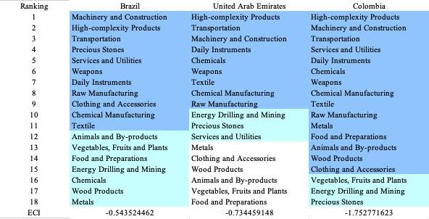
Table 5a. Opportunity Gain Ranking on a Comparable Scale (2013)
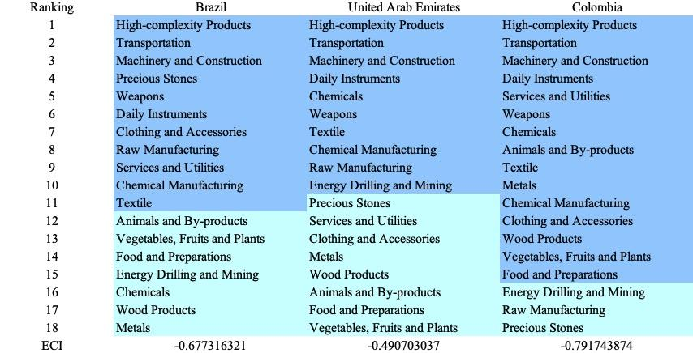
Table 5b. Opportunity Gain Ranking on a Comparable Scale (2018)

We define the ranking of opportunity gain for a country c, as the Suggested Development Vector (SDV) of c. Tables 5a-5c summarize how the SDV of Colombia compares with a selected group of comparable and leading economies in the world, with the industry groups ranked in decreasing order of significance. We focus on SDV results for 2018 because they give the most accurate snapshot of complexity for global comparison in the absence of the irregular effects of the COVID-19 pandemic observed in 2021.

Dark blue indicates positive opportunity gains, light blue indicates zero opportunity gains, and white indicates negative opportunity gains. The result shows that leading countries barely have any industries with positive opportunity gain. In other words, those countries are already in the most stable and efficient economic structure. Without the necessity of economic transition, those countries merely need to maintain a steady and balanced economic development. In contrast, developing countries have nearly half of the industries with positive opportunity gain, while more advanced economies share common interests in Chemicals. It can be concluded that Colombia shares the characteristics of developing countries, with a balanced economic structure that leans towards more complex industries.

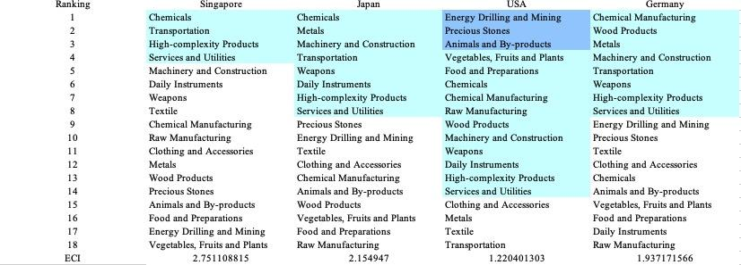
Table 6. SDV of Other Sample Countries (2019)

4.2 Budgeted Industry Development Strategy and Interpretation
The optimal budgeted industry development strategy aims to solve the most efficient allocations under the budgeted constraint of different situations of heuristic total export growth. In order to obtain such an allocation portfolio, we formulate an optimization problem as the following:



where k(x) is the second largest eigenvector of $M_{CC'}$ after adding $x$ to the original export vector, C is the country that we are interested in, P is the product space, B is the heuristic budget.

If we can solve this problem, then we can know what the largest ECI to which a country can improve. Accordingly, the optimal solution $x*$ that we obtain here is exactly our optimal allocation. However, the biggest problem is that the objective function is not convex. Therefore, we cannot apply the classical tools for convex optimization to this problem. In order to solve this problem, our idea is to use a greedy algorithm. The way that we apply the greedy algorithm is that firstly we separate the total budget into k equal parts, and then for the first equal part we try to search for the product that can optimize our objective function by iterating through each $p∈P$. After we find the optimal product p for this equal part, we add the amount back to the export value of this product p and update the ECI for this country. If we observe that ECI does not change after iterating all the products, then we can add up one more equal part to invest. Until we find there is an ECI increment, we add the amount now to that product. The equal rest parts can be done in the same way.

By definition, a greedy algorithm is a kind of local search algorithm that is possible to run into a local minimum. Therefore, for local search algorithms, one typical way to keep it away from the local minimum is to enhance the vision of the algorithm by looking more steps forward. In our setting, whenever we obtain an increment of ECI, we mark down the required amount of export growth. Simultaneously, we continue searching for the next ECI increment point, compare the ratios of these two possibilities and pick the largest one. The ratio is defined as the following:

where ${ECI}_{p}$ is just the ECI of the country after adding some amount of export increment to product $p$, which is exactly the amount that is able to make ECI change. Also, we can express it in the way of $||x_{p}-x_{0}{||}_{1}$.

In this way, we can obtain a further sighted greedy algorithm. Also, the number of parts that we would like to separate the budget into also matters. In order to solve this problem, we added a stabilizer on top of the enhanced greedy algorithm by running the algorithm for different numbers of parts and selecting the portfolio with the largest ECI increment and most complex economic structure.

Besides, it is quite common that there is a surplus in the budget. To deal with the surplus, we just add it to the product which needs the least amount of dollars to make $M_{cp}$ = 1 (i.e., the smallest amount of required export increase).

Economic Panel
As stated above, the enhanced greedy algorithm is developed mainly for solving the optimal allocation strategy. In order to visualize this allocation, an economic panel is created, consisting of a pie chart, a line chart and a table. First, a pie chart is used to show the percentage of each product in the optimal portfolio. The number located in the center of the circle denotes the heuristic growth of total export, which is also our budget. Each category in the chart has a determined percentage of the allocated budget. The lines below the pie charts show how the ECI changes during the searching process of the greedy algorithm. Even though sometimes an increase of the export by 15% or 20% does not seem reasonable to developed countries, yet it can also give a sense of how a country should develop in the long term. Eventually, the graph in the end is just for numerical explanation for the pie charts.

Interpretation
For the purpose of a clear explanation of the line charts, we label all the products in Table 7. Please refer to this table when trying to understand the investment trajectories in the line charts.

Label | Product Names
1 | Animal and By-products
2 | Vegetables, Fruits and Plants
3 | Food and Preparations
4 | Energy Drilling and Mining
5 | Chemicals
6 | Chemical Manufacturing
7 | Raw Manufacturing
8 | Wood Products
9 | Clothing and Accessories
10 | Textile
11 | Metals
12 | Machinery and Construction
13 | Transportation
14 | Weapons
15 | Daily Instruments
16 | Precious Stones
17 | High-complexity Products
18 | Services and Utilities
Table 7. Products Labeling

Figures 4a-4c show an economic panel for Colombia in 2013, 2018, and 2021. We can see that for different percentages of heuristic total export growth, the ECIs of Colombia actually have different increments. From all four-line graphs, we see that Colombia already obtains some great increment in terms of ECI. Most importantly, the higher the budget is, the greater the ECI will be. This means that in both the short term and long term, Colombia still has great room to improve. For the case of 5 percent growth, the ECI increment is because of the Services industry, Chemical Manufacturing, and Food Products. For all cases, we see that the portfolio contains many products, meaning that opportunities for increasing ECI are much larger than in other countries, whose portfolio typically dominates by one or more products.

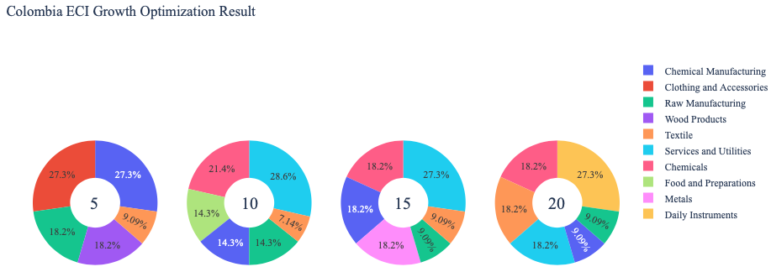
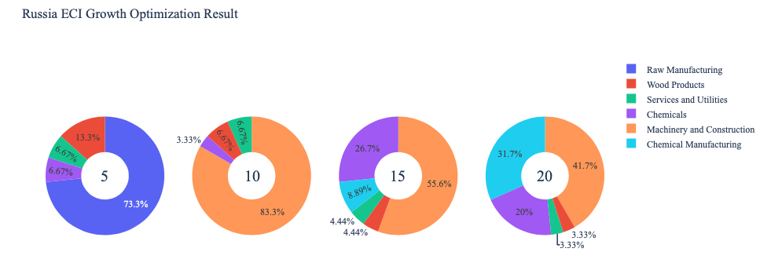
Figure 4a. Greedy-Based ECI Improvement Results of Colombia with Different Budgets (2013)

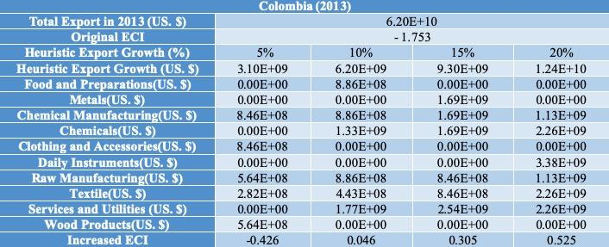
Table 8a. Portfolio of Colombia (2013)

For further suggestions on Colombia’s development in the future, we also offer the optimization result based on its export data in 2018. Below is the economic panel for Colombia in 2018. We can see that for different percentages of heuristic total export growth, the ECI growth pattern of Colombia is similar to the one in 2013. From all the four-line graphs, we see that Colombia can obtain some great increment in terms of ECI. Most importantly, the higher the budget is, the greater the ECI will be. This means that in both the short term and long term, Colombia still has great room to improve. For the case of 5 and 10 percent growth, ECI increment can be attributed to the development of Wood Products. For the case of 15 and 20 percent growth, ECI can grow much higher than the previous two cases, mainly because of the introduction of Machinery and Construction. Therefore, for future strategy, Colombia should prioritize the development of these industries in order to optimize ECI.

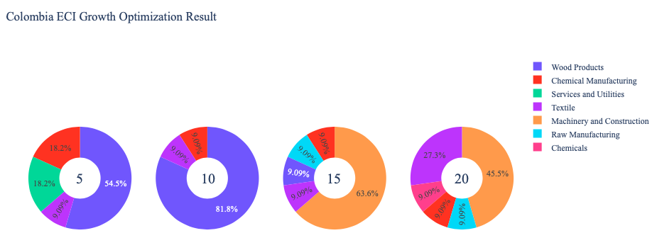
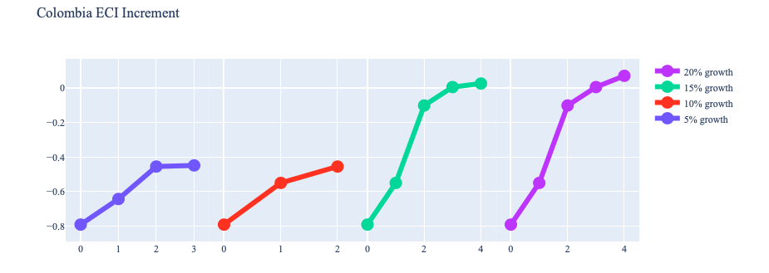
Figure 4b. Greedy-Based ECI Improvement Results of Colombia with Different Budgets (2018)

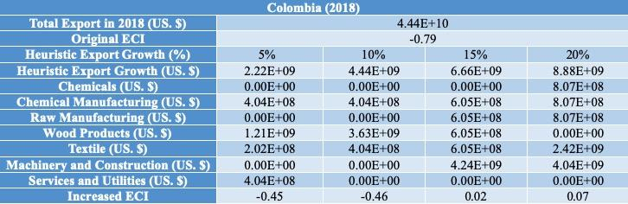
Table 8b. Portfolio of Colombia (2018)

To compare with the performance in 2013 and 2018, we also re-examine suggested strategies for 2021. For 2021, a 5 and 10 percent increase in export would emphasize Animals and By-products and Transportation for 15 and 20 percent export growth. These strategies go in line with the suggested trajectories based on ECI. A more detailed numerical representation of the portfolio for Colombia is shown in Table 8c.

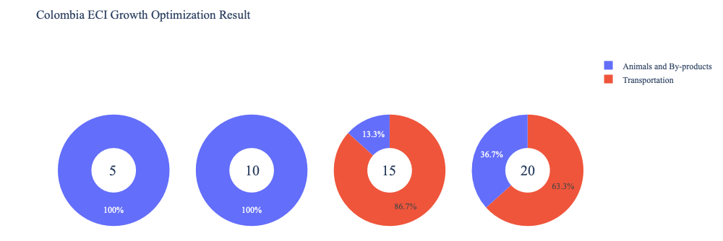
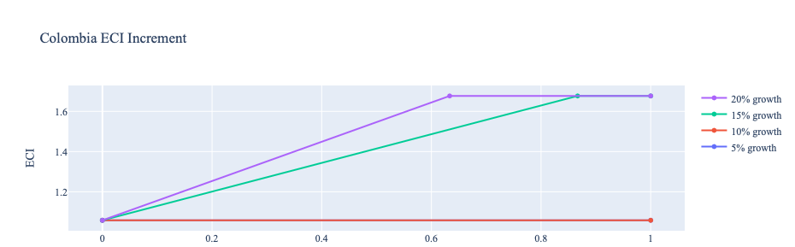
Figure 4c. Greedy-Based ECI Improvement Results of Colombia with Different Budgets (2021)

Colombia (2021)
Original ECI | -1.69
Heuristic Export Growth | 5% | 10% | 15% | 20%
Animals and By-products | 2.14E+09 | 4.28E+09 | 8.56E+08 | 3.14E+09
Transportation | 0.00E+00 | 0.00E+00 | 5.56E+09 | 5.42E+09
Increased ECI | 1.06 | 1.06 | 1.68 | 1.68
Table 8c. Portfolio of Colombia (2021)

4.3 Sensitivity Analysis and Contingency Strategy
In the following section, our broad aim is to understand how sensitive Colombia is to changes in export in various industries. While the Economic Complexity Index has been shown to contain valuable information about the economic strength/capacity of a country, little has been said as to the stability of the measure itself. We seek to uncover the main drivers of stability under a country's ECI score and better understand longer-term projections for ECI growth. Additionally, gaining an intuition on the industries that are bolstering an economy and the industries that offer the greatest return per unit of investment is best done through visualization of industry-specific sensitivity. To this end, we have developed two categories of sensitivity analysis.

ECI Sensitivity Graph
First, in order to assess the effect particular industries have on each respective country, we developed ECI Sensitivity graphs (Figure 5). We use the shocking methodology to increment or decrement an industry’s export level by a certain percentage and recalculate the ECI, all else being equal. While freezing the export dynamics of the rest of the world and enacting an instantaneous shock in export for a particular industry and country may not reflect real-life dynamics, what it does offer us is an understanding of a country’s level of dependency on an industry in the context of ECI. The shocking is done in small percentage increments in order to smooth out the resulting curve. Additionally, a recurring theme one will see is that for most industries, a breaking point occurs where the ECI either jumps upwards or downwards, creating a hockey stick shape rather than a linear trend. While the inflection point may not be accurate in the context of real life, comparing the various inflection points across industries can give us valuable insight.

Figure 5. Sample ECI Sensitivity Graph (2018)

The graphs are formulated as follows. There are six ECI Sensitivity graphs, two for each of the following years: 2021, 2018, and 2013. The first chart, Incremental ECI Sensitivity, shows positive shocking in which export numbers are shocked upwards per industry. The X-axis is in terms of percentage shock per current dollar value of export. The Y-axis is the recalculated ECI level post-shocking. The second chart, Decremental ECI Sensitivity, follows the same format except the X-axis represents negative shock. In other words, exports for each industry are decremented, and the ECI is accordingly recomputed.

SDV Sensitivity
Secondly, we analyze the sensitivity of the SDV to changes in export levels. The goal is to understand how export level changes for a particular industry can affect the marginal opportunity gain for other industries. We will use High Complexity Products and Food and Preparations as our base industries. We will be increasing or decreasing the absolute export level in both of these industries and observing the effects on the SDV.

When the opportunity gain of an industry is negative, the SDV sensitivity approximates how an over-development of the industry jeopardizes the economic structure of a country. When the opportunity gain of the industry is zero, the SDV sensitivity determines whether the further development of the industry shapes the country with a better economic structure and predicts how the SDV would change accordingly. Specifically, as we reduce the export of such an industry to 25% - 50% of its original value, a few other industries originally with negative opportunity gain could likely become profitable.

Similar to the ECI sensitivity graphs above, we will be shocking the export of High Complexity Products and Food and Preparations in small percentage increments. A new SDV, represented by a new column in the charts, is recorded only when a certain level of shock changes the structure of the SDV. In effect, we are incrementing or decrementing export levels of two industries until the marginal opportunity gain of any industry changes in category (positive, negative, or neutral). Below is an example of an SDV Sensitivity chart with Positive Shocking. Industries with positive marginal opportunity gain are colored blue, neutral is colored white, and negative is colored red.

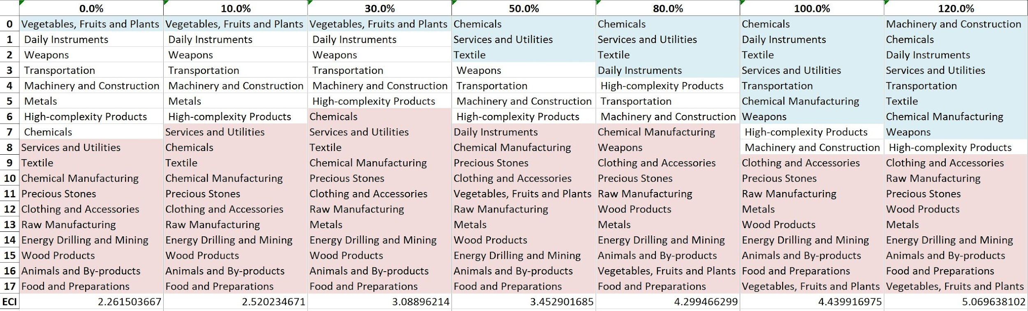
Table 9. Sample Incremental SDV Sensitivity for High-Complexity Products (2018)

Contingency Plan
The Contingency Plan aims to present a set of solutions with respect to upheavals in different industries. Instead of compensating for the declining production directly, the best strategy is to develop those incipiently profitable industries. In this manner, we can derive a contingency strategy for countries to deal with possible abrupt declines of crucial industries. In some cases, the SDV remains unchanged even when a zero-opportunity-gain industry declines to 20% in terms of export. We can then conclude the industry is not indispensable to the country. As a clarification, the three consecutive N/As mean that the country doesn’t even need to respond to a collapse in the industry. Countries tend to have distinct solutions to the ups and downs of the same industry. To create the contingency strategy table, we decrease the export level for each industry in the country’s current production space by 60% respectively. The three highest-ranking industries in the new SDV are then returned.

Product Names | 0 | 1 | 2
Animal and By-products | Services and Utilities | Daily Instruments | Weapons
Vegetables, Fruits and Plants | Services and Utilities | Daily Instruments | Weapons
Food and Preparations | Services and Utilities | Daily Instruments | Weapons
Energy Drilling and Mining | Services and Utilities | Daily Instruments | Weapons
Chemicals | Services and Utilities | Daily Instruments | Weapons
Chemical Manufacturing | Services and Utilities | Daily Instruments | Weapons
Raw Manufacturing | Services and Utilities | Daily Instruments | Weapons
Wood Products | Services and Utilities | Daily Instruments | Weapons
Clothing and Accessories | Services and Utilities | Daily Instruments | Weapons
Textile | Services and Utilities | Daily Instruments | Weapons
Metals | Services and Utilities | Daily Instruments | Weapons
Machinery and Constructions | Services and Utilities | Daily Instruments | Weapons
Transportation | Services and Utilities | Raw Manufacturing | Daily Instruments
Weapons | Services and Utilities | Daily Instruments | Transportation
Daily Instruments | Services and Utilities | Weapons | Transportation
Precious Stones | Services and Utilities | Daily Instruments | Weapons
Daily Instruments | Services and Utilities | Daily Instruments | Weapons
Services and Utilities | Daily Instruments | Weapons | Transportation
Table 10. Sample Contingency Strategy (2018)

4.3 Sensitivity Analysis Results and Interpretation
We examine Colombia's ECI Decremental and Incremental Sensitivity Charts for 2021. An increase in Chemical Manufacturing will lead to the highest change in ECI, followed by Vegetables, Fruits, and Plants. The strong sensitivity effect of manipulating the Chemical Manufacturing category remains consistent with previous years. For the negative shock cases, the Energy and Drilling industry becomes the most impactful, and it also remains consistent with the previous years. The rest of the industries do not appear to have the same level of sensitivity.

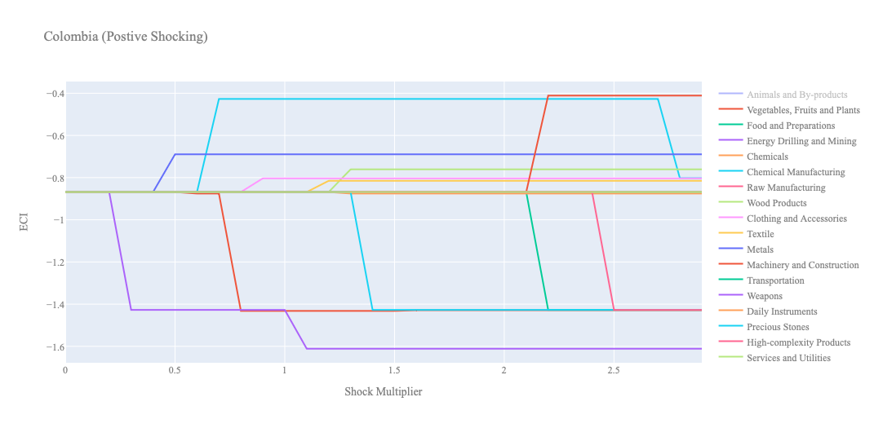
Figure 6a. Incremental ECI Sensitivity for Colombia (2021)

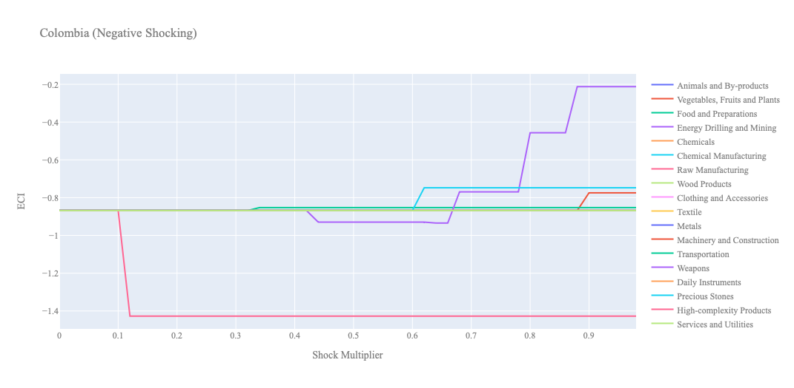
Figure 6b. Decremental ECI Sensitivity for Colombia (2021)

Below is Colombia's 2018 ECI Sensitivity Charts. First, in the positive chart, we notice that only Chemical Manufacturing and Textile offer significant increases in ECI when exports are expanded. Even with these expansions, the ECI does not climb out of the negative territory. Quite a few industries, in fact, worsen the ECI score when exports are increased, as we can see below.

In Figure 7b, we consider Colombia’s 2018 Negative Shock chart. We can see that Colombia is fairly insensitive to the majority of its industries. Export decreases in Energy & Drilling, as well as Precious Stones, actually improve the ECI of the country. The only industry that Colombia is highly sensitive to is Raw Manufacturing.
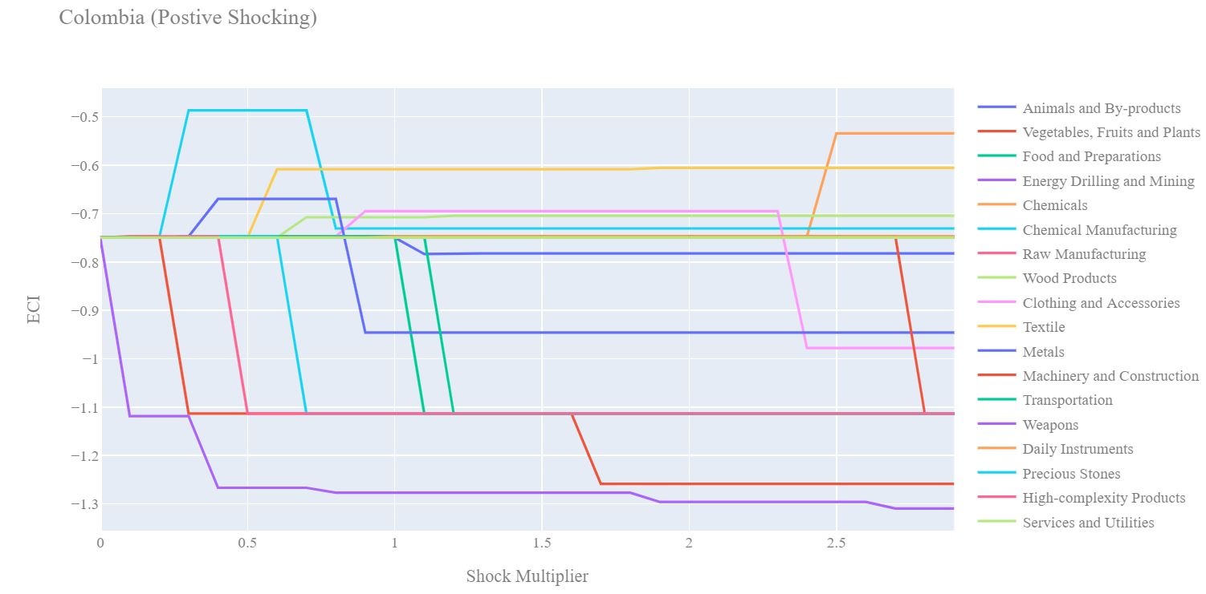
Figure 7a. Incremental ECI Sensitivity for Colombia (2018)

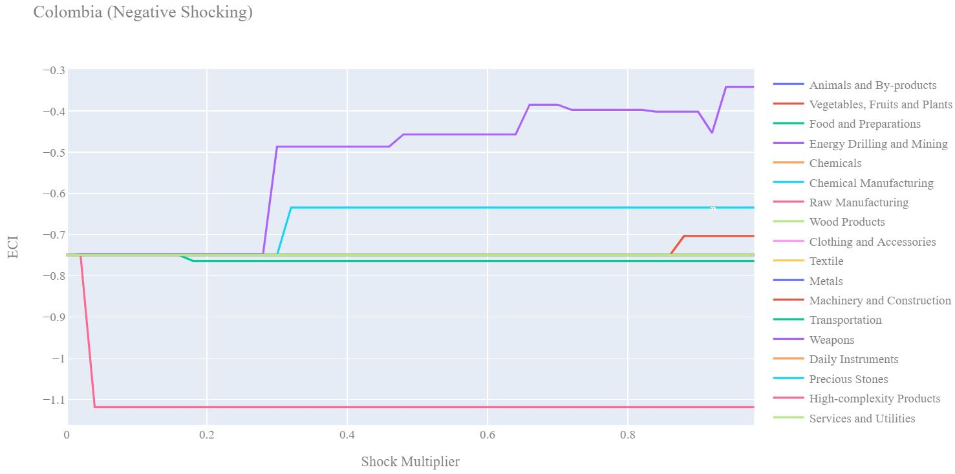
Figure 7b. Decremental ECI Sensitivity for Colombia (2018)

Next, we consider the 2013 ECI Sensitivity graphs (Figures 8a and 8b). We see that in the positive shocking case, we have quite a few more industries that are attractive in terms of increasing ECI. Increases in the export of Chemicals, Raw Manufacturing, Textiles, Metals, Wood Products, and a few others all lead to significant ECI gains. It must be considered, however, that in 2013 Colombia has a much lower ECI rank of -1.25 rather than -0.75 in 2018.

In the 2013 negative shocking case, we see that Colombia is fairly insensitive to the majority of its industries. Again, a decrease in the export of Energy and Drilling drastically improves the ECI score, while other industries have little effect on ECI gain.
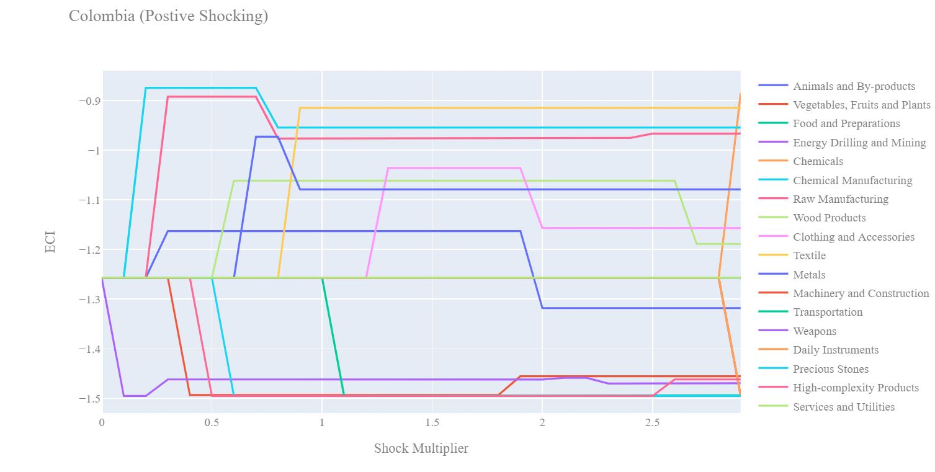
Figure 8a. Incremental ECI Sensitivity for Colombia (2013)

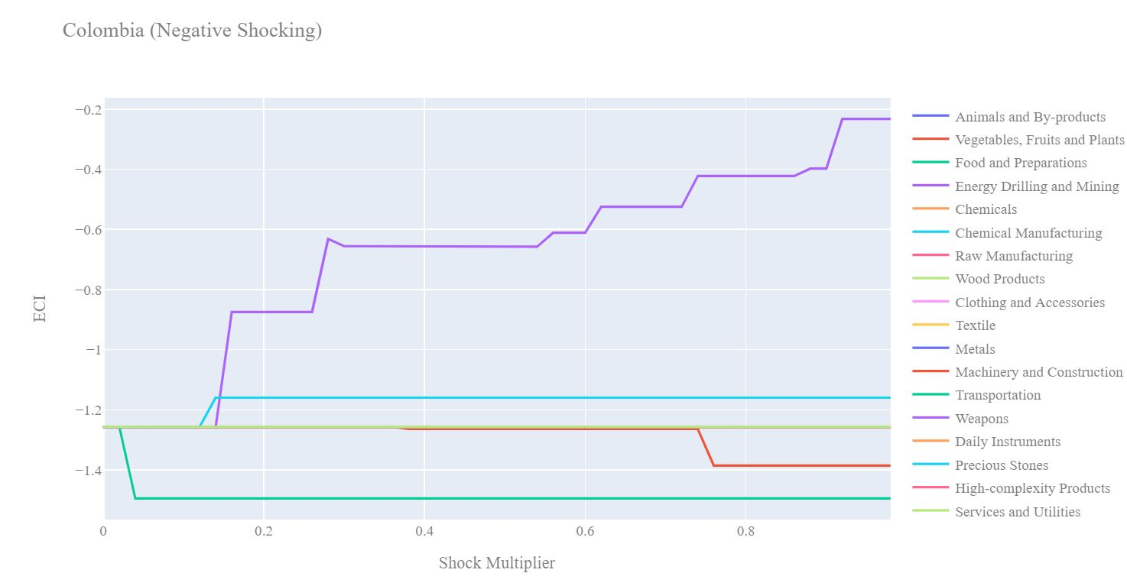
Figure 8b. Decremental ECI Sensitivity for Colombia (2013)

Below we see the SDV sensitivity charts for High Complexity Products. We see that in both positive and negative shocking scenarios, Colombia is fairly insensitive to changes in the export level of High Complexity Products. We can see that there are quite a few industries that offer positive opportunity gain and are unaffected by Colombia's export levels in High Complexity Products.

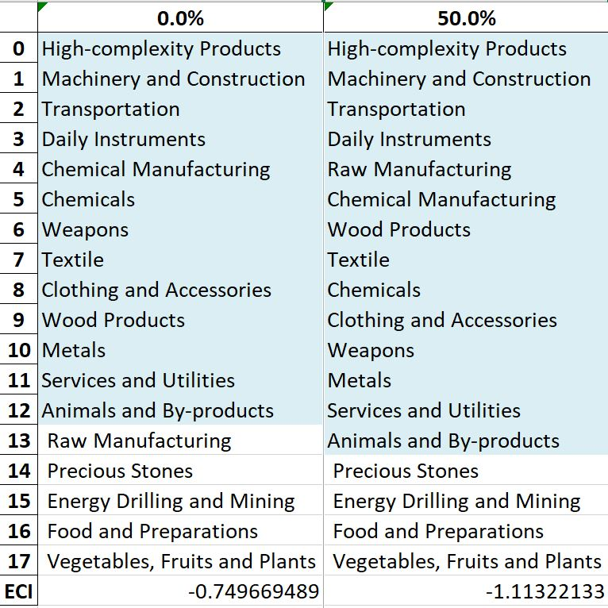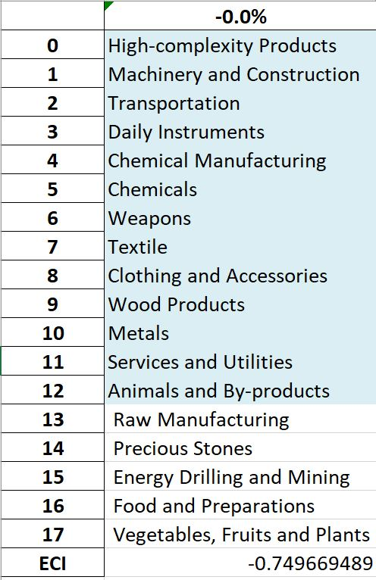
Table 11. Colombia’s SDV Sensitivities for High-Complexity Products (2018)

Table 12 show SDV sensitivity charts for Food and Preparations. The same can be said about the Food and Preparations Industry. In both the positive and negative shocking scenarios, Colombia is fairly insensitive to changes in the export level of Food and Preparations. We can see that there are quite a few industries that already offer positive opportunity gains and are unaffected by Colombia's export levels in Food and Preparations.

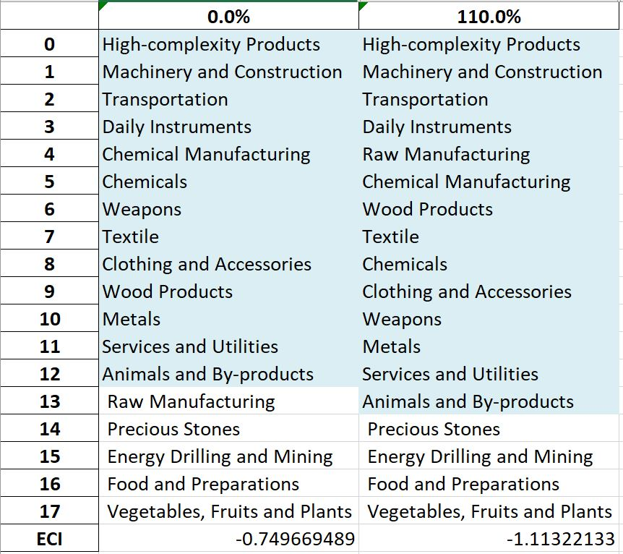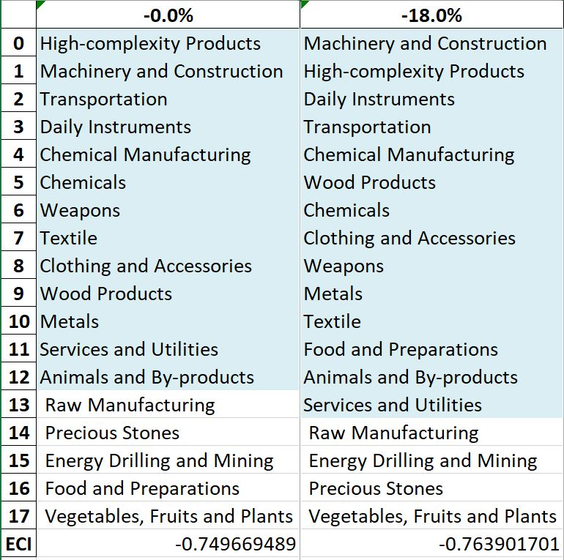
Table 12. Colombia’s SDV Sensitivities for Food and Preparations (2018)

5. Macro-level Predictions

5.1 Structural Optimality Index
ECI sensitivity, described in the section before, has proven to be a significant factor in deciding the economic outcomes of countries. In order to quantitatively evaluate how effective our development strategies are and how deviations from the suggested developmental path will lead to suboptimal growth results, we define the measure – Structural Optimality Index (SOI) – on a country level as the Adjusted R-Square obtained from regressing the country’s realized industry development over the suggested development strategy. Both strategies are quantified in nature, with the realized development represented by increasing export in every major industry group and the suggested development strategy represented by the opportunity gains of developing the corresponding industry groups as calculated in previous sections. The adjusted R-square from the regression thus provides us with a quantified measure of how the development path adopted by the country has fitted with/differed from calculations on a complexity level.

After obtaining this measure for all countries in our database, we further regress countries’ five-year economic growth, which is defined as the percent increase in GDP (USD), over their SOI. Figure 9 illustrates the regression output, which shows a strong positive correlation between countries’ SOI and their five-year GDP growth, significant at the 2% level and achieving an adjusted R² of 0.054. In other words, the more a country develops, as suggested by calculations on a complexity level, the better economic outcomes it achieves.

Table 14: OLS Regression Results
Dep. Variable: GDP | F-Statistic: 5.963
R²: 0.054 | Prob (F-Stat): 0.0163
Adj R²: 0.045 | No. Observations: 106


Figure 9. Regression of Five-Year GDP Growth over SOI (2013-2018)

5.2 SOI of Colombia and Its Implications
Colombia, for instance, has a low level of structural optimality as compared with its developed peers. As the regression in Figure 10a suggests (the red curve represents an export increase, and the blue curve stands for opportunity gain of the corresponding industry), Colombia demonstrates a low level of correlation with the suggested developmental path, having an adjusted R-square of around 0.023 in 2021.

Colombia ranks in the third quartile among all countries in terms of SOI and has made slow economic progress among its emerging peers from 2013 to 2018 with a 5-year GDP growth rate of 2.1%, which is consistent with the regression result in Figure 4b. This is in direct contrast to China, with corresponding GDP growth of 8.2% from 2013 to 2018, making it one of the fastest-developing economies during the period.

Specifically, Colombia's slow economic progress from 2013 to 2018 can be at least partially explained by a development strategy that demonstrates a considerable but not perfect level of matches with our suggested developmental path. In specific, Colombia invested heavily in Food and Preparation and Textile, while it should have focused more on industry groups such as Raw Manufacturing, Energy Drilling and Mining, and Metals.

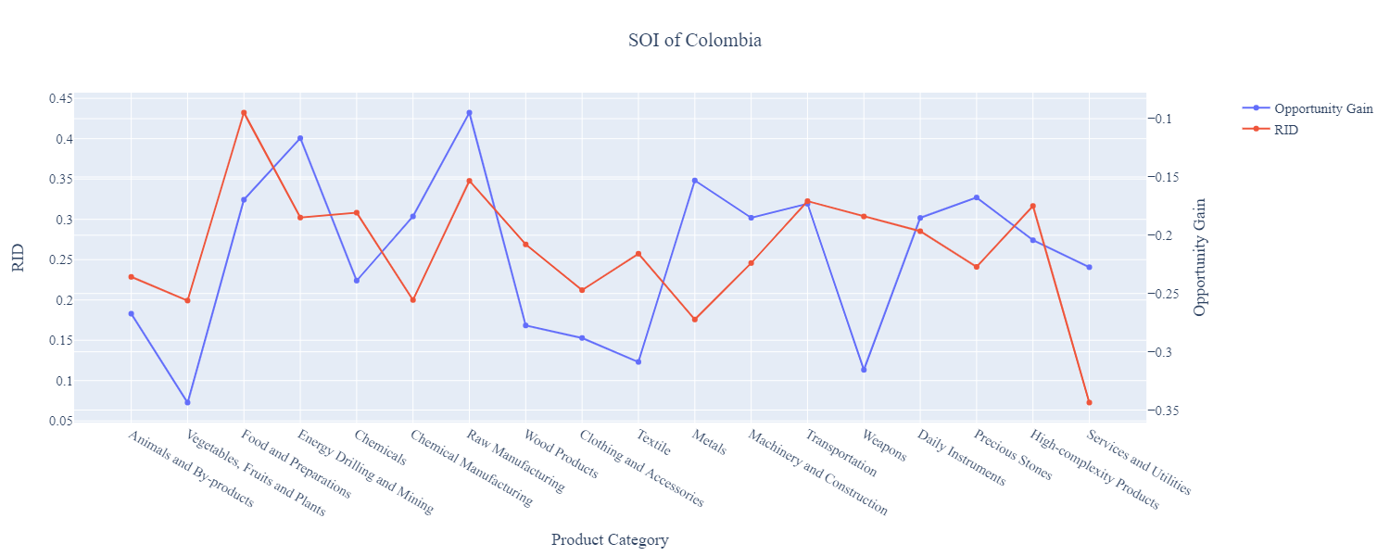
Figure 10a. SOI of Colombia (2013-2018)

For the 2019-2021 years, Colombia has a strong presence in Machinery and Construction, High-Complexity Products, which seem to have depleted its potential to boost RID. Energy Drilling and Mining, the highest industry by RID, also present the best opportunity for further investment. It also could consider Textiles (unlike in 2013-2018), Metals, and Clothing and Accessories to improve its growth. Colombia has seen a slight average growth in GDP over those three years of 0.2%, compared to 2.1% for the average yearly growth for the five years prior. Colombia also ranked in the third quartile among all countries in terms of SOI.

Much lower than before, its adjusted R-squared value of 0.23 indicates a weaker correlation between GDP growth and the implemented development path. Progress is slow on a global scale during this period, and Colombia demonstrates a slower ability to adjust to negative economic shocks by improving SOI and increasing GDP growth than it did between 2013 and 2018.

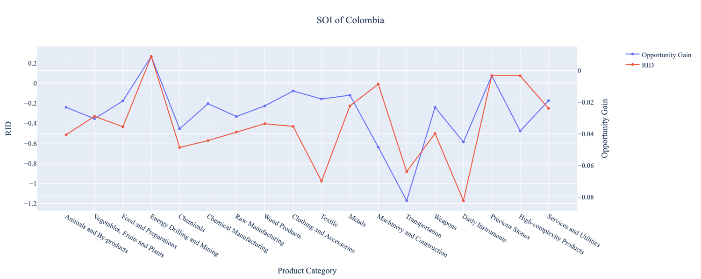
Figure 10b. SOI of Colombia (2019-2021)

6. Concluding Remarks

In conclusion, Colombia has demonstrated a low level of economic growth in terms of annual GDP increase during the period from 2013 to 2018, concurrent with an increase in economic complexity as compared with major developed economies. For 2019-2021, the growth in GDP had an upward trend, alongside a large boost in ECI, higher than that of other comparable countries and even some of the leading economies in the world.

We believe that the mixed progress during the first period can be partially explained through the analysis of the economic and product complexity structure of Colombia on the industry group level. The product classification system we adopt allows us to measure the realized industry development for various industry groups and to observe that Colombia progressed in developing some of its industries during the period while some of its developed counterparts and emerging economies around the globe adopted much more complex and progressive paths.

Based on our analysis of the opportunity gain and sensitivity analysis of major industry groups for 2013-2018, Colombia can further its gains by prioritizing Machinery and Construction and Chemical Manufacturing. We further note that Colombia has a less efficient development strategy that indicates a lower level (compared to other developed countries) of structural optimality on the complexity level, having an adjusted R-square of around 0.054. Since a low positive correlation exists between five-year GDP growth and the structural optimality index of an economy as we define and calculate, Colombia indeed has experienced suboptimal growth as compared with fast-growing economies both on a regional scale and on a global scale and has the potential to further its economic gains through industrial structure optimization as suggested in the paper.

During the second examined period, from 2019 to 2021, Colombia performed much weaker than before and compared to other countries, particularly Mexico and Saudi Arabia. We infer that during the COVID-19 period, Colombia focused on developing higher complexity industries despite a downturn for these industries, given the global economic downturn. We also note that Colombia has increased its investment in the sectors identified earlier, leading to a boost from Machinery and Construction High-Complexity Products industries, leaving some room for strategic improvement. It did invest in the industries which contributed the most to its advancements, such as Energy and Mining industries. The ECI suggests that greater growth could have been achieved through Animals and By-products and Transportation. The instability also decreased the adjusted R-squared value to 0.023 in 2021 from 0.054 in 2018, demonstrating that the pursued strategies did not contribute to the GDP to the fullest. With the revised focus, Colombia has further potential to advance its economic growth to maintain its position among other countries to continue its post-pandemic recovery.

References

Hausmann, R., Hidalgo, C., Bustos, S., Coscia, M., Chung, S., Jimenez, J., Simoes, A. and Yıldırım, M. (2007). The Atlas of Economic Complexity. [online] Atlas.cid.harvard.edu. Available at: http://atlas.cid.harvard.edu/.

Balassa, B., “The Purchasing Power Parity Doctrine - A Reapprais- al,” Journal of Political Economy 72, 584-596 (1964).

Feenstra, R.; Lipsey, R.; Deng, H.; Ma, A. & Mo, H. “World Trade Flows: 1962-2000” NBER working paper 11040. National Bureau of Economic Research, Cambridge MA (2005).

United Nations Commodity Trade Statistics Database (http://comtrade.un.org/db/), accessed in August 2019.

The World Economic Forum, “The global competitiveness report,” (various years).

Barro, R. & Lee, J-W. “A New Data Set of Educational Attainment in the World, 1950-2010,” NBER Working Paper No. 1590 (2010).

Kaufmann, D. & Kraay, A. “Governance Indicators: Where Are We, Where Should We Be Going?” Policy Research Working Paper 4370. Washington, DC: World Bank (2008).

Hanushek, E.A. & Woessmann, L. “The Role of Cognitive Skills in Economic Development,” Journal of Economic Literature 46(3), 607- 668 (2008).

